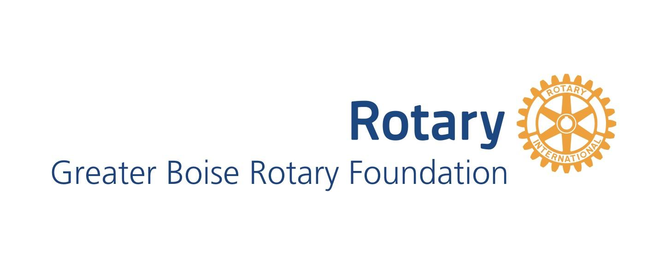
Grant Application Guidelines 2019-2020

The Greater Boise Rotary Foundation (GBRF) is a charitable endowment fund that provides support to community programs and organizations in Ada County, or serving citizens of Ada County. The GBRF seeks to maximize and leverage collective resources to serve the citizens of Ada County by awarding grant funds to requesting agencies. This document outlines the funding priorities, allowable items, and process.
Granting Priorities and Eligibility:
The GBRF granting priorities align with the Vision Statement and focus areas of Rotary International.
Rotary International’s Vision Statement
“Together, we see a world where people unite and take action to create lasting change — across the globe, in our communities, and in ourselves.”
Rotary International’s Six Areas of Focus
Rotary is dedicated to six areas of focus to build international relationships, improve lives, and create a better world to support our peace efforts and end polio forever.
- Promoting peace
- Fighting disease
- Providing clean water, sanitation, and hygiene
- Saving mothers and children
- Supporting education
- Growing local economies

GBRF granting priorities address the areas of focus for Rotary International and cater to the specific needs of Ada County. The GBRF granting priorities include:
- Support for fine and preforming arts, including music, theater and dance (#5 Supporting education)
- Educational opportunities for all ages (#5 Supporting education)
- Health care and social services (#2 Fighting disease; #3 Providing clean water, sanitation, and hygiene; #4 Saving mothers and children)
- Outdoor and recreational improvements (#6 Growing local economies)
- College scholarships for promising students at Boise State University (#5 Supporting education)
- Programs that enrich lives and futures of youth (#1 Promoting peace; #5 Supporting education)

Eligibility: Non-Profit. 501 (c)(3) organization principally active in Ada County who address one or more of the Foundation’s funding objectives.

The Foundation will only fund expenses directly related to the distinct project and/or initiative described in the grant application. Grant awards will be based solely on your grant application and concrete examples of your organization’s work in the community.

The Foundation will not fund:
- Consultant fees
- Fellowships
- Endowments
- Cash reserves
- Political campaigns
- Fund raising expenses
- Accumulation followed by subsequent granting to other organizations.

Grants will be awarded based upon:
- Alignment of proposal objectives with the Foundation’s Funding Objectives and the ideals of Rotary,
- Clarity of project goals and strategies to address stated needs and goals
- Impact of project on Ada County

The annual deadline for receipt of applications for small grants is March 15th. Award decisions are finalized in May. Funds are distributed during the month of June.

Grant Award Expectations:
A final report describing the utilization of grant funds, the number of people served by the program or project, and the achievement of objectives stated in the grant request is required. For large grants, greater than $5000, reports progress reports are due to GBRF by September 1st. For small grants, reports are due to GRBF no later than December 1st of the year after the grant is awarded (if awarded in June of 2019, report is due December 2020). Failure to submit a report may disqualify the grantee from future grant eligibility.

